- Introduction
1.1 Description of the Problem
Calgary, a cosmopolitan Alberta city with numerous skyscrapers, owes its rapid growth to its status as the centre of Canada’s oil industry. However, it’s still steeped in the western culture that earned it the nickname “Cowtown,” evident in the Calgary Stampede, its massive July rodeo and festival that grew out of the farming exhibitions once presented here.

1.2 Discussion of the Background
My client runs a successful restaurant chain in the Eastern Region of Canada with 5 restaurants spread between Ottawa, Toronto and a Montreal now wants to explore the western restaurant market and has decided to start with the City of Calgary.
As a restaurant owner, it is important that your business is not too close to competitors while ensuring that it is also close to major attractions in the city. Therefore, my client wants to know the best are to locate the new restaurant that will be have the least competition and the most attractions.

1.3 Target Audience
This project is to anyone that wants to set up business in Calgary and will like to know what the competition hotspot is like around the city.

- Data
This project relies on public data from Wikipedia and Foursquare.
The neighbourhoods in Calgary is gotten from the Wikipedia page "https://en.wikipedia.org/wiki/List_of_neighbourhoods_in_Calgary" which serves as the foundation for the analysis.
Data about venues in Calgary were gotten from the FourSquare API. Additional analysis was performed by my client to provide a weighted rank of how much competition or attract a venue type is on a scale of 1-10.
For example, an hotel has a higher rank of attraction (10) and a minimal rank of competition (1) giving it a total weight of 9 (10-1).
However, a Pizza Place is a direct competitor and has a lower attraction rank of (3) and a medium competition rank of (6), giving it a total weight of -3 (3-6).
The expectation is that for a cluster of venues, we take the average of all venue weights and the cluster with the highest average weight is the best location for our restaurant.

- Analysis
Extracted the list of neighbourhoods from Wikipedia using the panda's read_html method
to obtain a dataframe containing Calgary's neighbourhoods.
Used the geocoder library to search for the GPS coordinates of the each neighbourhood.
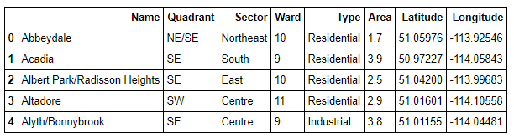
Looped though each neighbourhood to obtain the first 200 venues within a 2000m radius. This is enough to cover the whole city.
Note that there are duplicated venues that fall within 2000m of multiple neighbourhoods, therefore when the listing was merged, the duplicates were removed.
Obtained a listing of the categories of all the venues obtained and assigned Attraction and Competition weights to them.
Kmeans was used to create 20 cluster
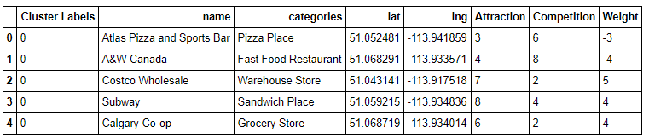

The Clusters are sorted for the highest average weight which is identified as cluster 14
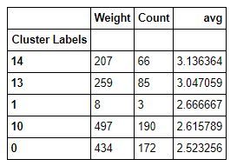
List of 5 venues in Cluster 14
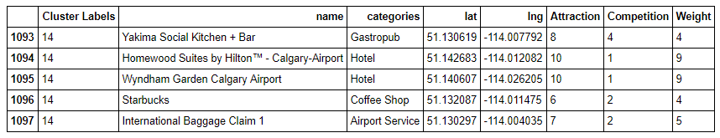
Plotted cluster 14 on the map and it turns out to be around the Airport
